St. Thomas Aquinas
Catholic Secondary School Community
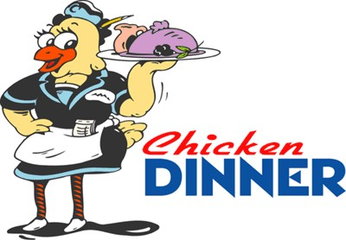

Thursday, October 20th
5:30pm to 7:30pm
Adults $15.00
Students/Seniors $12.00
Children under 13 $5.00
Children under 2 Free
Family $40.00
(2 Adults, up to 2 Children under 13)

Dine-in or Take-out
(Bring your own take-out containers)
Menu
Ginny’s Special Chicken
Roasted Potatoes
House Salad with a bun
Homemade Deserts/Ice Cream
Coffee, Tea, Pop or Water

Tickets available at the school

905-936-4743

Susan Bonney x354 or Sharon Duggan x352
Hope To See You There!

